Omurama Data Pipeline – Open Source Technology Stack

1. Overview
This technology stack is designed to support Omurama’s full data lifecycle — from ingestion to analytics — across batch and real-time (streaming) systems. It ensures scalability, reliability, local hosting capability, and compliance with Uganda’s Data Protection and Privacy Act (2019).
It supports structured, semi-structured, and unstructured data such as text, images, video, logs, and sensor data.
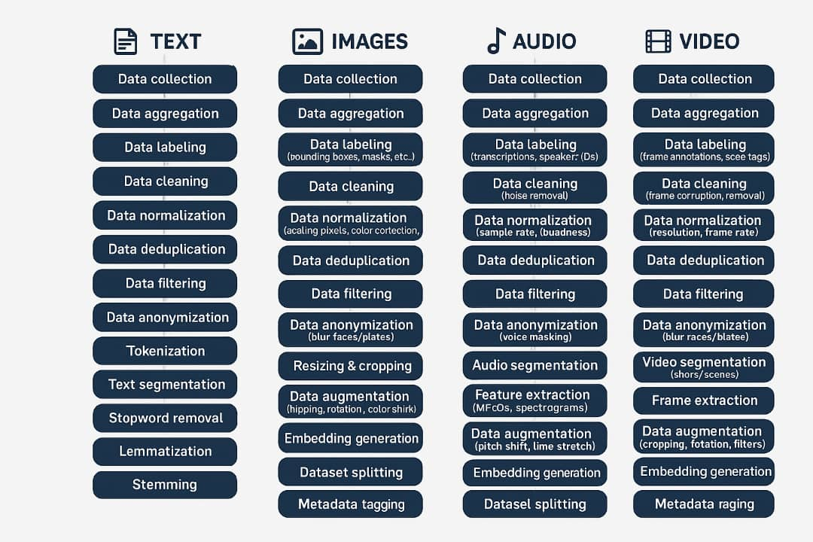

2. Pipeline Architecture Layers

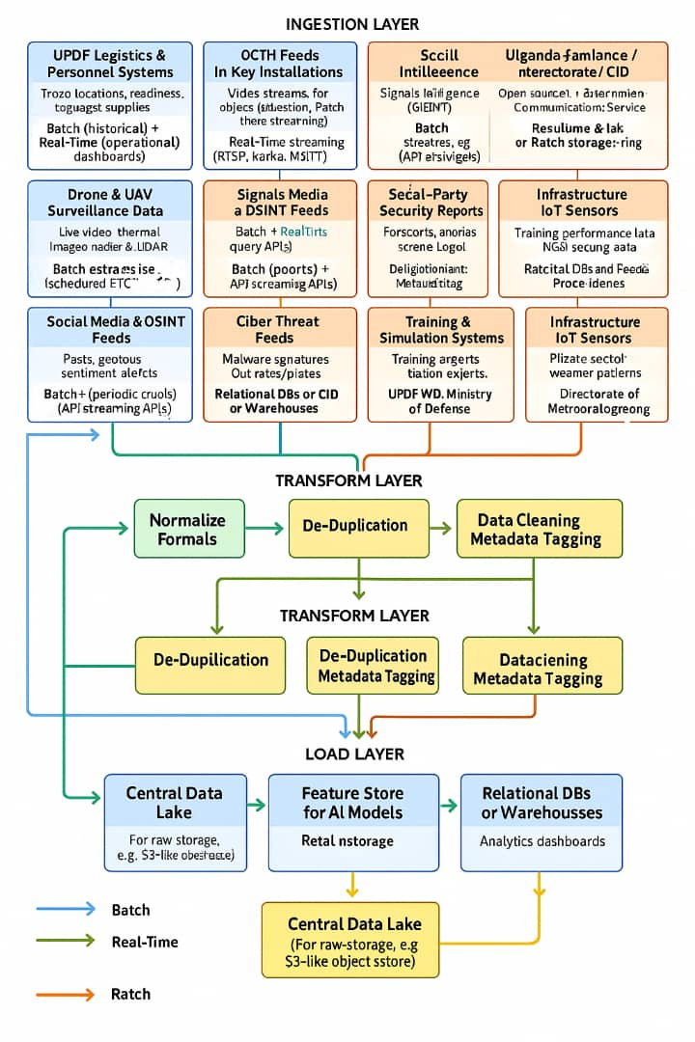
Layer | Purpose | Recommended Open-Source Technologies
Data Sources | Collect data from systems, devices, and sensors | APIs, Databases, CCTV/RTSP, IoT sensors, CSV/JSON/XML files, Social media APIs, Web logs
Ingestion Layer | Securely ingest both batch and streaming data | Batch: Apache NiFi, Airbyte, Talend Open Studio, Pentaho Kettle  Streaming: Apache Kafka, Apache Pulsar, MQTT brokers, Apache Flume
Staging / Landing Zone | Temporary or raw immutable data storage | HDFS, MinIO (S3-compatible), Ceph, Apache Ozone
Processing / ETL Layer | Clean, transform, and enrich data | Batch: Apache Spark, Apache Beam, dbt (Data Build Tool), Apache Hop  Streaming: Apache Flink, Kafka Streams, Spark Structured Streaming
Storage Layer | Store raw, curated, and serving data | Structured: PostgreSQL, ClickHouse, MySQL, Apache Iceberg, Delta Lake  Unstructured: Hadoop HDFS, MinIO, Ceph, Mongo DB, Elasticsearch
Data Warehouse / Serving Layer | For analytics, queries, and dashboards | Apache Druid, Apache Pinot, Trino (PrestoSQL), ClickHouse, DuckDB
Data Lakehouse (optional unified layer) | Unified lake + warehouse for structured & unstructured data | Apache Iceberg + MinIO, Delta Lake + Spark
Metadata & Governance Layer | Schema registry, cataloging, lineage, and access control | Apache Atlas, Amundsen, OpenMetadata, Schema Registry (Confluent/Redpanda), Apache Ranger
Security & Privacy | Encryption, IAM, | Vault (HashiCorp), Keycloak (OIDC/IAM),
Layer | monitoring, PDPO compliance | Apache Ranger, ELK Stack (SIEM), OSSEC/Wazuh
Monitoring & Observability | Monitor pipeline health, latency, and data quality | Prometheus, Grafana, ELK (Elasticsearch, Logstash, Kibana), OpenTelemetry, Airflow Metrics
Workflow & Orchestration | Schedule, coordinate, and monitor data jobs | Apache Airflow, Dagster, Luigi, Argo Workflows
Machine Learning Layer | Model training, deployment, and registry | MLflow, Kubeflow, TensorFlow Extended (TFX), DVC (Data Version Control)
Visualization & Reporting | Business intelligence and dashboards | Apache Superset, Metabase, Redash, Grafana
Data Quality & Validation | Automated data testing & quality checks | Great Expectations, Deequ, Soda Core
Backup & Disaster Recovery | Ensure high availability and data retention | MinIO replication, Ceph mirroring, Velero (for Kubernetes), Rclone backups

3. Data Types and Handling
Data Type | Handling Strategy | Storage / Tool Example
Structured Data (SQL tables, logs) | ETL using dbt or Airflow + Spark | PostgreSQL, ClickHouse, Trino
Semi-Structured Data (JSON, XML, CSV, API responses) | Schema-on-read using Spark, Flink, or Presto | Delta Lake, Iceberg, HDFS, MinIO
Unstructured Data (Images, Video, Audio, PDFs) | Object storage and metadata indexing | MinIO / Ceph + Elasticsearch
Streaming Data (CCTV, IoT, social media) | Real-time ingestion, PII masking, and aggregation | Apache Kafka + Flink
Text / NLP Data (from CIVA, ASA) | Tokenization, entity recognition, embedding’s | Elasticsearch, Hugging Face Transformers
Sensor & IoT Data | Edge buffering → MQTT → Kafka → Flink | MQTT, InfluxDB, TimescaleDB

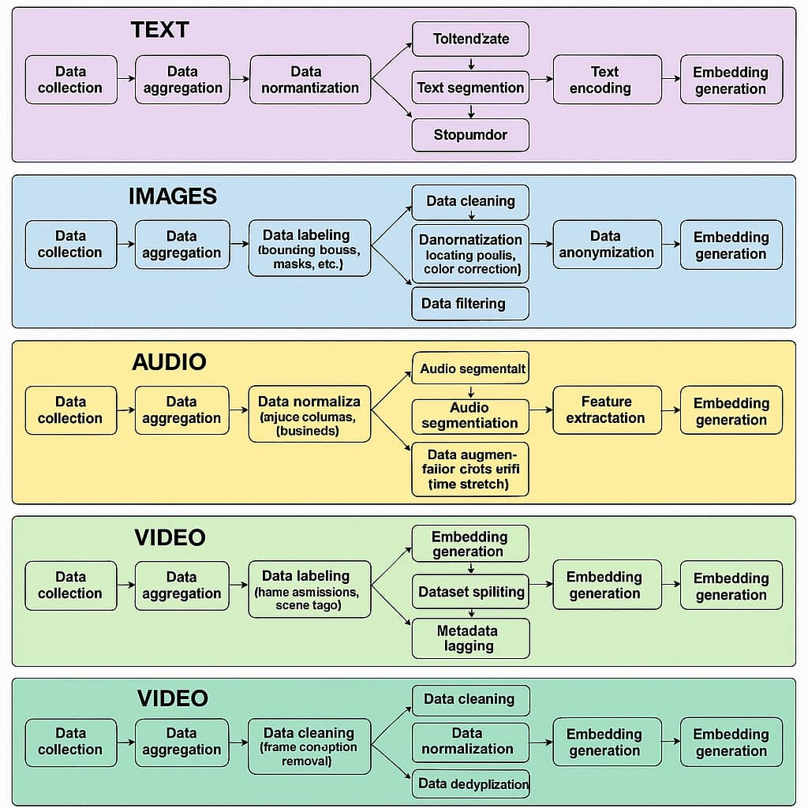

4. Batch ETL Workflow (Typical)
- Extract: Data imported via NiFi or Airbyte from APIs, DBs, and files.
- Load (Landing): Raw data stored in MinIO or HDFS.
- Transform: Spark or dbt cleans, joins, and enriches data.
- Load (Curated): Transformed data saved in Iceberg or Delta Lake tables.
- Serve: Data loaded into ClickHouse or Trino for dashboards and ML pipelines.
- Monitor: Airflow + Prometheus track job health, data quality via Great Expectations.

5. Real-Time ETL Workflow (Typical)
- Stream Capture: Kafka or Pulsar ingests logs, IoT, and video metadata.
- Stream Processing: Flink or Spark Streaming performs filtering, enrichment, and aggregation.
- Schema Enforcement: Confluent Schema Registry validates event structure.
- Storage: Real-time writes to ClickHouse or Druid for instant analytics.
- Alerts: Stream anomalies trigger Prometheus/Grafana and send alerts to Slack/Email.
- Governance: Apache Atlas logs lineage and Ranger enforces access rules.

6. Security & Compliance
- Identity & Access: Keycloak for OAuth2 / OpenID Connect with RBAC.
- Encryption: TLS 1.3 in-transit, AES-256 at-rest using Vault-managed keys.
- Auditing: Apache Ranger + Atlas for user access tracking and lineage visualization.
- Compliance: DPIA, PDPO registration, automated data retention enforcement.
- Incident Response: Wazuh SIEM + Airflow alerts to security officers.

7. Infrastructure & Deployment
Layer | Open Source Stack Options
Containerization | Docker
Orchestration | Kubernetes, OpenShift OKD, K3s (for small clusters)
Storage Backend | Ceph, MinIO, HDFS
Compute Frameworks | Spark, Flink, Airflow workers
Monitoring Stack | Prometheus, Grafana, Loki, Alert manager
Infrastructure as Code | Terraform, Ansible, Helm

8. Data Governance and Catalog Integration
Component | Purpose | Tool Example
Data Catalog | Discover, classify, document datasets | Apache Atlas, OpenMetadata
Schema Registry | Centralize data schemas | Confluent Schema Registry
Lineage Tracking | Visualize data movement | Apache Atlas
Access Policies | Enforce fine-grained access control | Apache Ranger
DPIA Automation | Track DPIA and compliance reports | Custom Omurama Compliance Module (built on OpenMetadata API)

9. Example End-to-End Tool Integration
For Real-Time AI and Analytics (CIVA, ASA, and Omurama Search):
CCTV / IoT → Kafka → Flink → MinIO (Raw) → Spark → Iceberg → Trino → Superset → MLflow (Model)
For Batch Data Warehousing:
API / CSV → NiFi → Airflow (ETL) → Spark → Delta Lake → ClickHouse → Superset
For Governance & Security:
Keycloak (Auth) + Ranger (Access) + Atlas (Lineage) + Vault (Secrets) + Grafana (Monitoring)

10. Advantages of the Omurama Open Source Stack
- 100% open-source and Uganda-hosted (no external dependency on foreign SaaS)
- Scalable across national data centers and local private clouds
- Built for AI readiness — integrates directly with MLflow, Hugging Face, TensorFlow
- Compliant with Uganda’s Data Protection and Privacy Act (2019)
- Flexible for future use cases: healthcare, intelligence, education, finance, and infrastructure data.

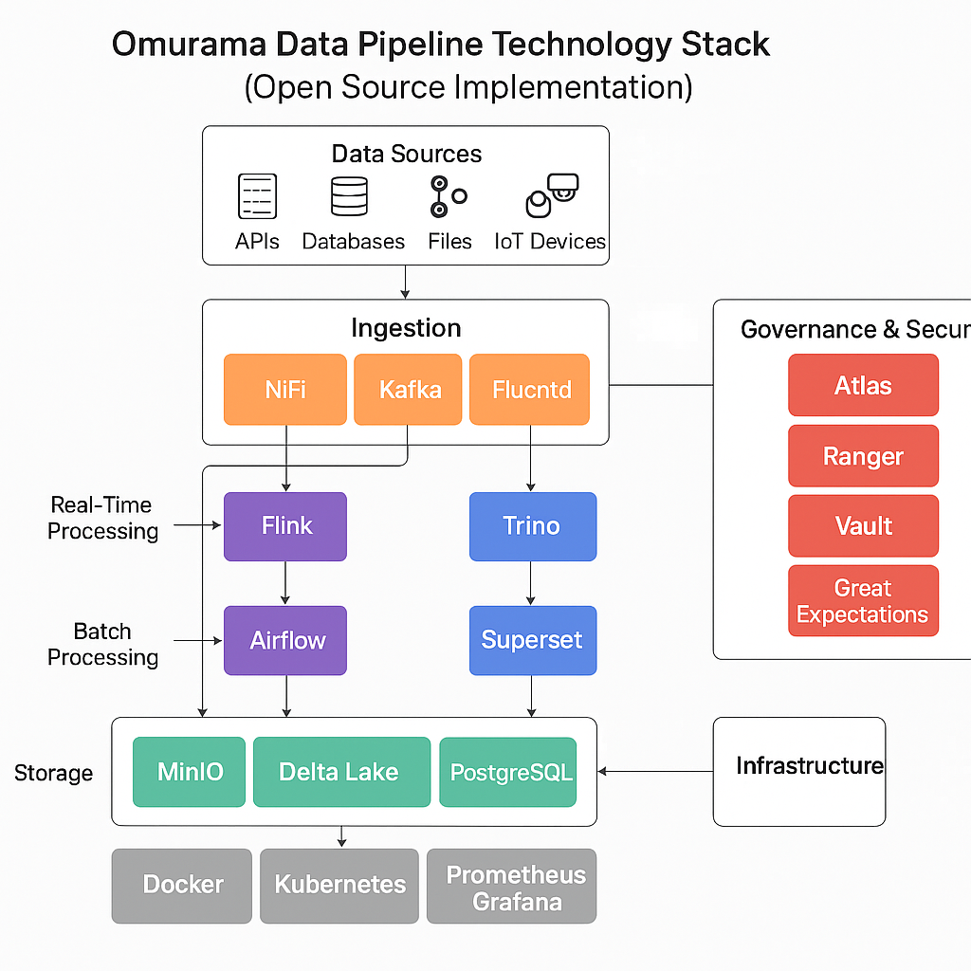

Best Open-Source Technology Stack for Omurama Data Pipeline

  - Data Ingestion Layer
Handles data collection from diverse sources (IoT, APIs, CCTV, databases, files, social media, etc.)
Purpose | Recommended Technology | Notes
Streaming Ingestion (Realtime) | Apache Kafka + Kafka Connect | Industry standard for high-throughput streaming. Supports connectors for CCTV feeds, logs, IoT, and social media.
Batch Ingestion (Periodic Data Loads) | Apache NiFi | Visual dataflow management, drag-and-drop design, supports file, DB, API, and cloud ingestion. Ideal for government or enterprise ETL.
Edge Data Capture | Fluentd or Filebeat | For logs, sensors, and CCTV data from local devices.

2. Message Queue & Stream Processing
Transforms, filters, and aggregates in motion.
Purpose | Technology | Description
Stream Processing | Apache Flink | Powerful for real-time analytics, fraud detection, alerts, and pattern recognition. Works natively with Kafka.
Alternate lightweight option | Spark Structured Streaming | Use this if you already deploy Spark for batch. It shares the same unified API for both batch and streaming.
Best combo: Kafka + Flink → native integration and fault-tolerant real-time analytics.

3. Batch ETL / ELT Layer
Performs large-scale transformations, joins, and data cleaning.
Purpose | Technology | Description
Batch Processing | Apache Spark | Unified analytics engine for batch ETL, ML, and SQL processing.
Data Orchestration | Apache Airflow | Schedules and manages ETL pipelines, ensuring dependencies and retries.
Workflow Integration | NiFi + Airflow | NiFi handles ingestion; Airflow handles workflow logic and scheduling.

Best combo: NiFi + Airflow + Spark — NiFi ingests → Airflow triggers → Spark transforms → warehouse.

4. Data Storage Layer
Houses structured, semi-structured, and unstructured data.
Data Type | Storage Technology | Notes
Raw (unstructured) | Hadoop HDFS or MinIO (S3-compatible) | For files, images, CCTV footage, documents, logs. MinIO preferred for cloud-native setup.
Processed (structured/semi) | Apache Hive / Delta Lake | Supports ACID transactions, metadata management, and time-travel.
Operational / Transactional | PostgreSQL or MariaDB | For real-time application and analytics use cases.
Search / Indexing | Elasticsearch | For fast search on documents, logs, and analytics dashboards.
Best combo: MinIO + Delta Lake + PostgreSQL + Elasticsearch — covers all formats and analytics needs.

5. Machine Learning & Analytics Layer
Extracts intelligence and supports AI models (like ASA, CIVA, and Omurama Search).
Purpose | Technology | Description
ML & Data Science | JupyterHub + MLflow + TensorFlow / PyTorch | Centralized environment for training, tracking, and deploying models.
BI Dashboards | Apache Superset or Metabase | Interactive analytics dashboards for non-technical users.
Query Engine | Presto / Trino | SQL queries across multiple data sources (Hive, Delta, PostgreSQL, etc.).
Best combo: Trino + Superset + MLflow — unified analytics and AI integration.

6. Data Governance, Security & Compliance
Ensures data protection per Uganda’s PDPA (2019) and NITA-U standards.
Area | Technology | Description
Data Catalog & Lineage | Apache Atlas | Tracks metadata and data movement across pipeline.
Data Quality & Profiling | Great Expectations | Defines and validates data quality rules.
Access Control & Encryption | HashiCorp Vault + Apache Ranger | Vault manages secrets; Ranger manages access permissions.
Compliance | Custom PDPO Compliance Module | Local scripts & dashboards for audits, incident reports, and DPIA logs.
Best combo: Atlas + Ranger + Vault + Great Expectations — full governance suite.

7. Infrastructure & Orchestration
Manages deployments, scaling, and monitoring.
Purpose | Technology | Description
Containerization | Docker | Encapsulates services (Kafka, Flink, Spark, etc.).
Cluster Management | Kubernetes (K8s) | Orchestrates containers, scaling, and resilience.
Monitoring & Logging | Prometheus + Grafana + ELK Stack | Metrics, dashboards, and centralized log management.
Best combo: Docker + Kubernetes + Prometheus + Grafana — modern, cloud-native deployment.

Final Recommended Core Stack for Omurama
Layer | Technology Stack
Ingestion | NiFi + Kafka + Fluentd
Processing (Realtime) | Kafka + Flink
Processing (Batch) | Airflow + Spark
Storage | MinIO + Delta Lake + PostgreSQL + Elasticsearch
Analytics / AI | Trino + Superset + MLflow
Governance & Security | Atlas + Ranger + Vault + Great Expectations
Infrastructure | Docker + Kubernetes + Prometheus + Grafana

